AI ASSISTED CODING ASSIGNMENT - 3.1

Srijith Rao

2303a51019

Task Description
Design and refine prompts using different prompting strategies to generate Python programs for basic computational problems.

Question 1: Zero-Shot Prompting (Palindrome Number Program)
Write a zero-shot prompt (without providing any examples) to generate a Python function that checks whether a given number is a palindrome.

Task Description
  - Record the AI-generated code.
  - Test the code with multiple inputs.
  - Identify any logical errors or missing edge-case handling.
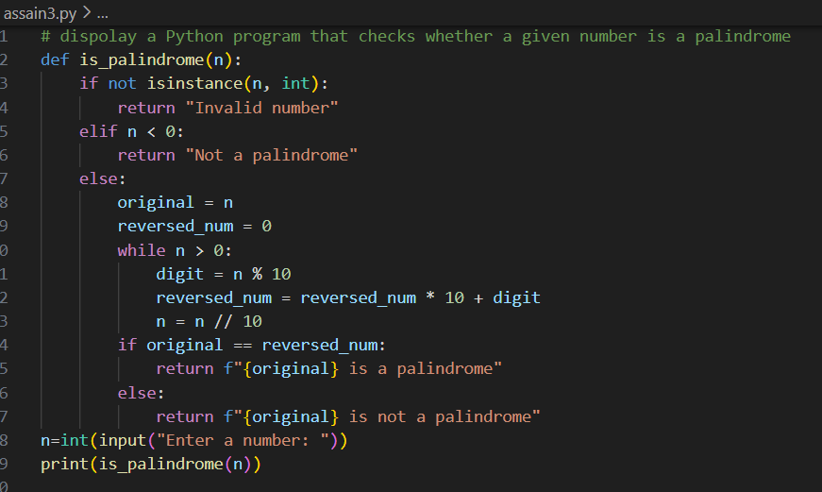

Question 2: One-Shot Prompting (Factorial Calculation)
Write a one-shot prompt by providing one input-output example and ask the AI to generate a Python function to compute the factorial of a given number.

Example:
  - Input: 5 → Output: 120

Task Description

  - Compare the generated code with a zero-shot solution.
  - Examine improvements in clarity and correctness.
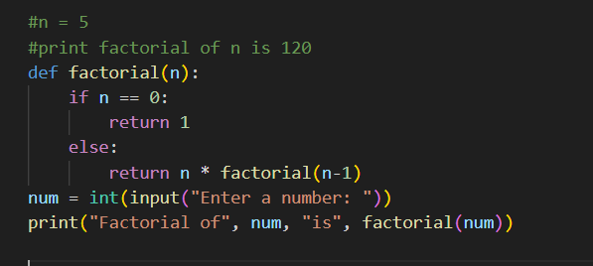

Question 3: Few-Shot Prompting (Armstrong Number Check)
Write a few-shot prompt by providing multiple input-output examples to guide the AI in generating a Python function to check whether a given number is an Armstrong number.

Example:
  - Input: 153 → Output: Armstrong Number
  - Input: 370 → Output: Armstrong Number
  - Input: 123 → Output: Not an Armstrong Number

Task Description
  - Analyse how multiple examples influence code structure and accuracy.
  - Test the function with boundary values and invalid inputs.

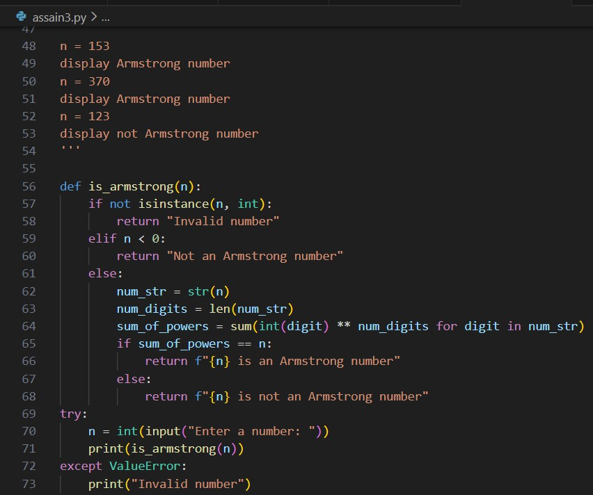

Question 4: Context-Managed Prompting (Optimized Number Classification) Design a context-managed prompt with clear instructions and constraints to generate an optimized Python program that classifies a number as prime, composite, or neither.

Task Description
  - Ensure proper input validation.
  - Optimize the logic for efficiency.
  - Compare the output with earlier prompting strategies.

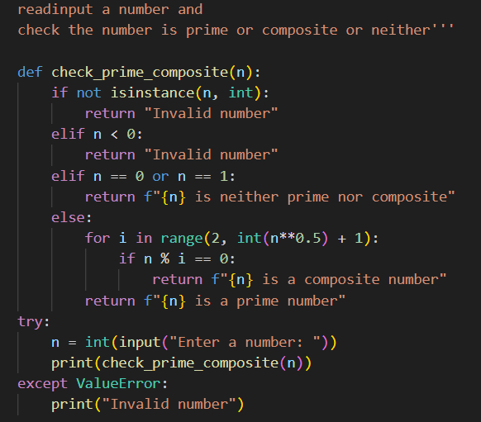

Question 5: Zero-Shot Prompting (Perfect Number Check)
Write a zero-shot prompt (without providing any examples) to generate a Python function that checks whether a given number is a perfect number.

Task Description
  - Record the AI-generated code.
  - Test the program with multiple inputs.
  - Identify any missing conditions or inefficiencies in the logic.

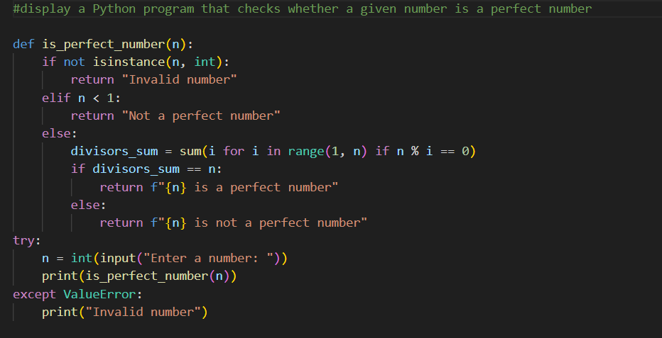

Question 6: Few-Shot Prompting (Even or Odd Classification with Validation) Write a few-shot prompt by providing multiple input-output examples to guide the AI in generating a Python program that determines whether a given number is even or odd, including proper input validation.

Example:
  - Input: 8 → Output: Even
  - Input: 15 → Output: Odd
  - Input: 0 → Output: Even

Task Description
  - Analyse how examples improve input handling and output clarity.
  - Test the program with negative numbers and non-integer inputs.

